Phase One

Required 9 Instructions
These are the minimum required operations implemented in the ALU:
- Addition (ADD) – Performs A + B
- Increment (INC) – Performs A + 1
- Decrement (DEC) – Performs A - 1
- Comparison (CMP) – Outputs 3 flags: Equal, Less than, Greater than
- Bitwise NOT – Performs NOT A
- Bitwise AND – Performs A AND B
- Bitwise OR – Performs A OR B
- Shift Right Logical (SHR) – Right shift of A
- Shift Left Logical (SHL) – Left shift of A
Additional 5 Suggested Instructions
- Bitwise XOR(A ⊕ B) is useful in many algorithms like parity checking, encryption, and CPU logic.
- Subtraction SUB(A - B) Allows full arithmetic support beyond just ADD and INC/DEC.
- PASS A(Output = A) Used to directly pass a register value to output, useful for move operations.
- Zero Check (IS ZERO) Output 1 if result == 0, Often used in loop and condition checks.
- Negative Check (IS NEGATIVE), Output 1 if the result is negative (MSB = 1 in two's complement) Essential for signed comparisons and conditionals.
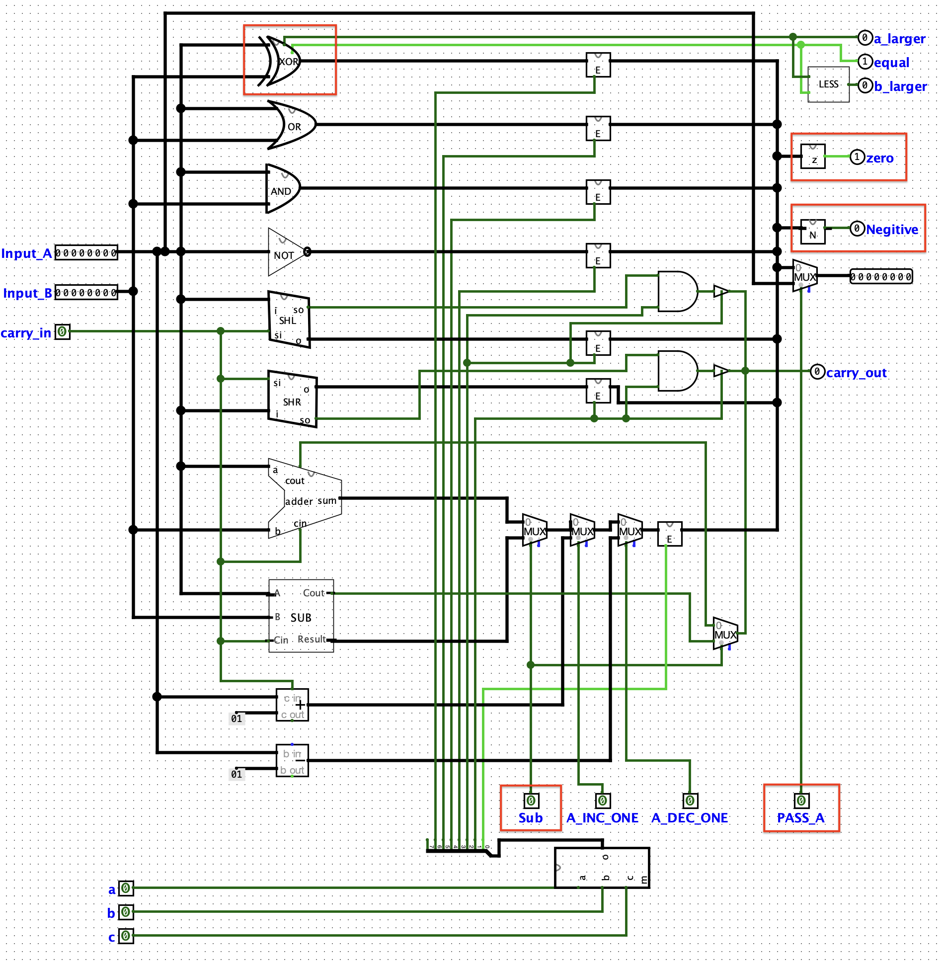

Phase Two

1.Create the opcode table
Binary Code | Instruction | Description
0000 | ADD | A + B
0001 | INC | A + 1
0010 | DEC | A - 1
0011 | CMP | Compare A and B (equal, less, greater flags)
0100 | NOT | Bitwise NOT A
0101 | AND | Bitwise A AND B
0110 | OR | Bitwise A OR B
0111 | SHL | Shift A left ; A << 1
1000 | SHR | Shift A right ; A >> 1
1001 | XOR | Bitwise A XOR B
1010 | SUB | A - B
1011 | PASS A | Output = A
1100 | IS ZERO | Output 1 if Result == 0
1101 | IS NEGATIVE | Output 1 if Result < 0 (MSB = 1)
1110 | BRZ | Branch if Zero – Jumps to label if a specified register is 0
1111 | BRLSB | Branch if LSB is 0 – Jumps to label if the least significant bit of a register is 0

2. Operand Structure
I chose to use two operands for each ALU operation: Input_A and Input_B.
The result is forwarded to the output or can be stored back in one of the inputs.
This allows greater flexibility and supports a wider range of arithmetic and logical operations.
Two-operand instructions are more powerful than single-operand ones and match common instruction formats in modern CPUs, such as ADD A, B.

3. Multiplexer and Instruction Selection
In my design, I used a multiplexer (MUX) to select the active ALU operation module.
The output of the selected module is chosen using the MUX, controlled by a 3-bit selector (a, b, c).
The selector is a custom circuit I built to act like an instruction decoder or control unit.
Phase Three
To select which ALU operation to perform, I used multiplexers (MUX) connected to the outputs of the ALU function blocks (e.g., ADD, AND, SHR, etc.). A 3-bit custom control signal (a, b, c) selects which operation output is forwarded. This multiplexer serves as the core of the Control Unit, as it determines which logic unit’s result will be passed on based on the instruction code.

Final ALU Testing
I tested the ALU by manually loading values into Input_A and Input_B, selecting one of the supported operations (ADD, AND, or SHR), and verifying that the correct result is output.

1. Addition (ADD) - A+B
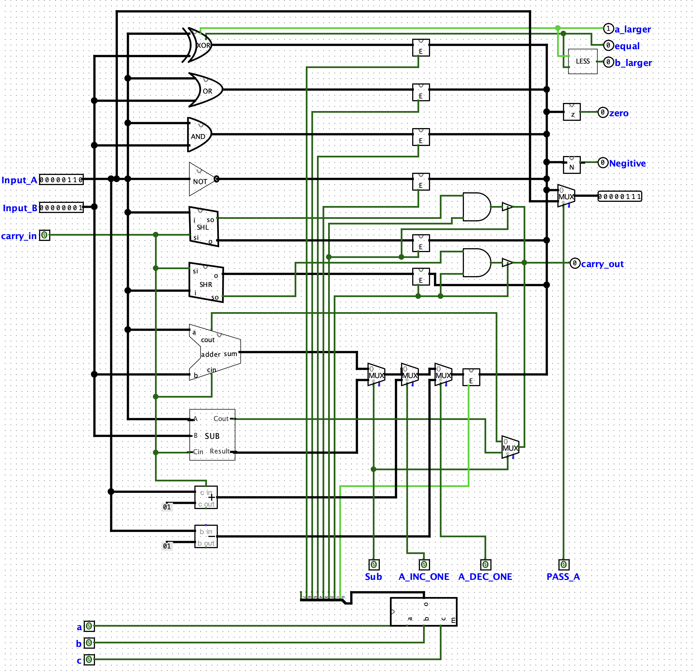

2. Bitwise AND - A AND B
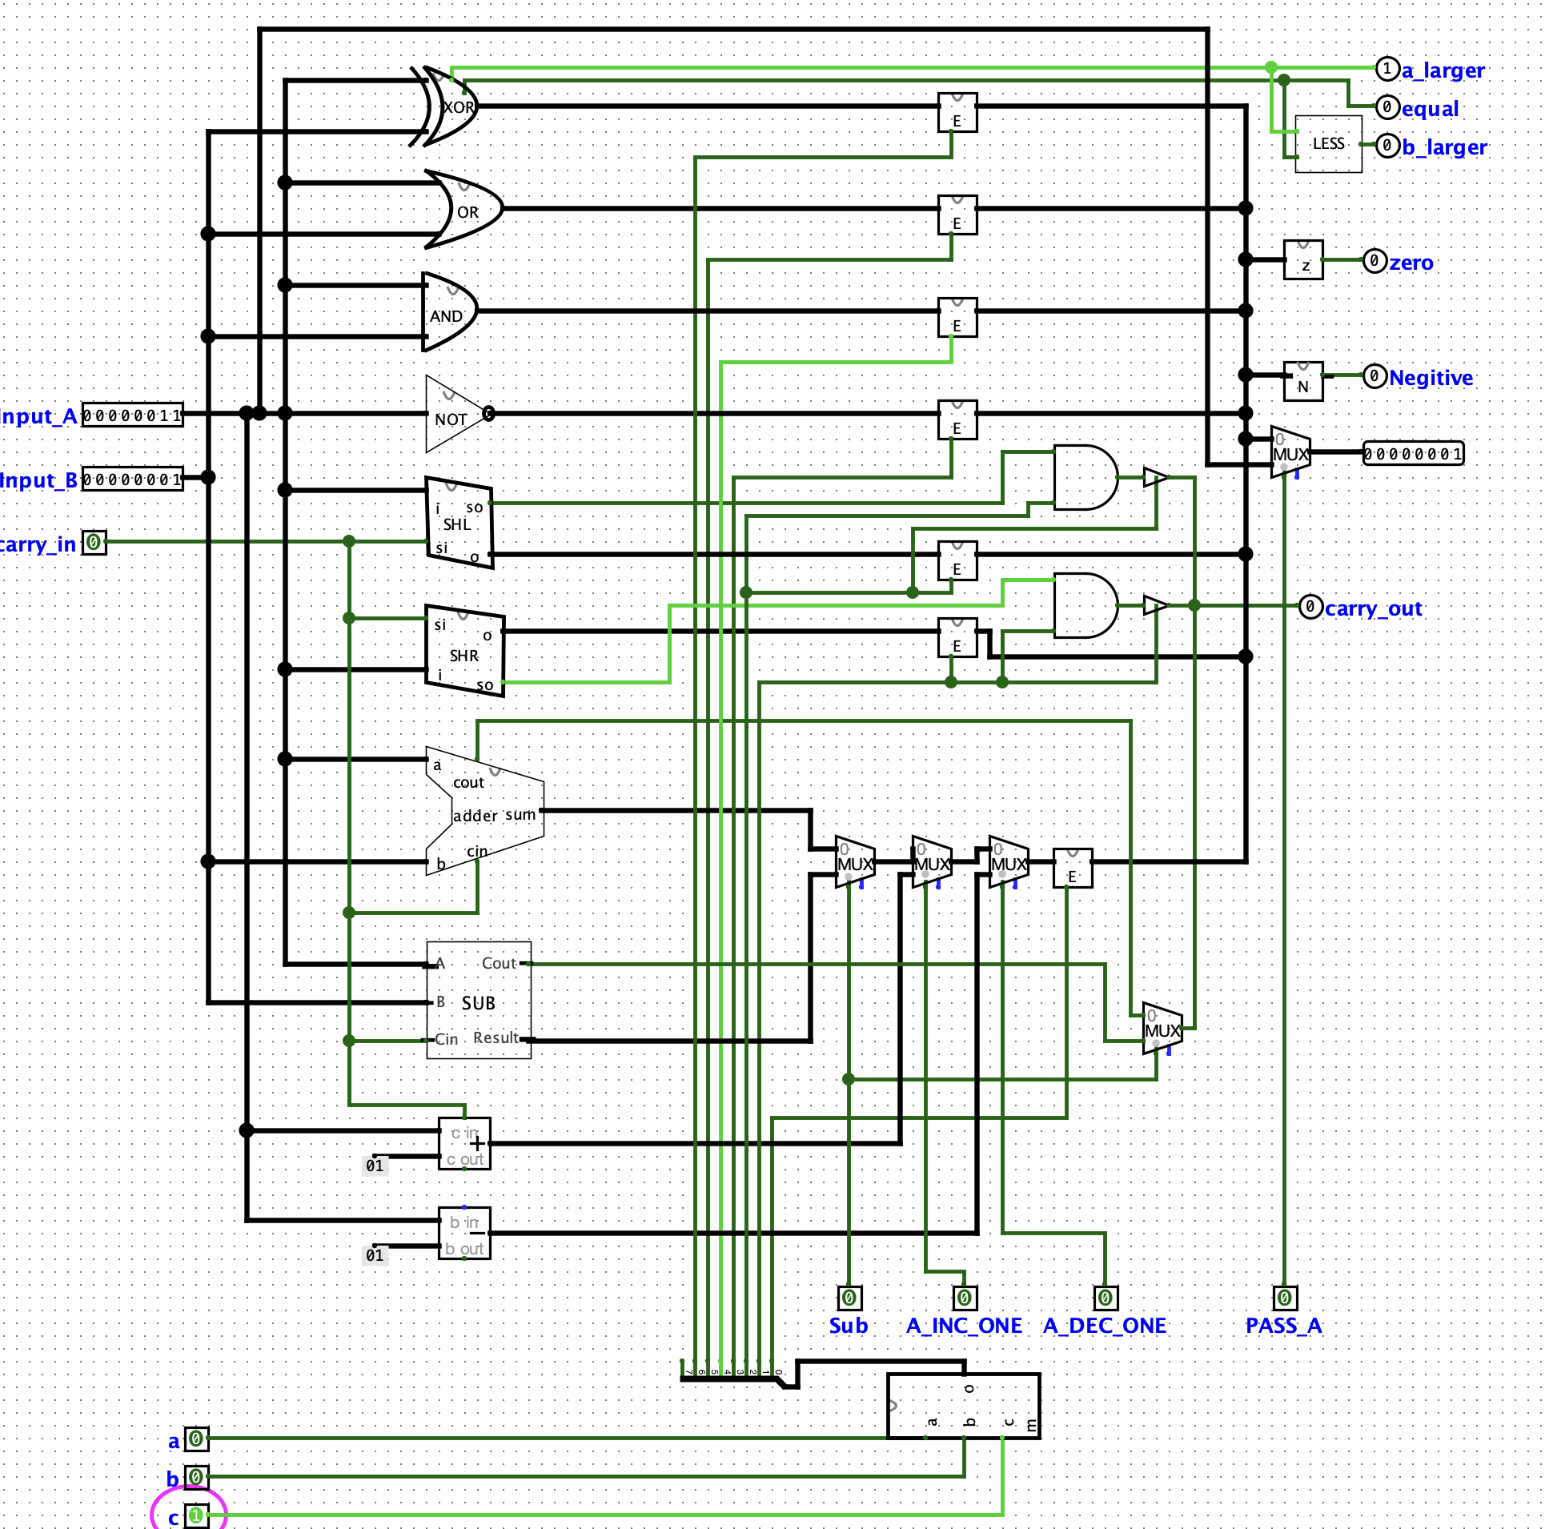

3. Logical Right Shift (SHR) - Shift A right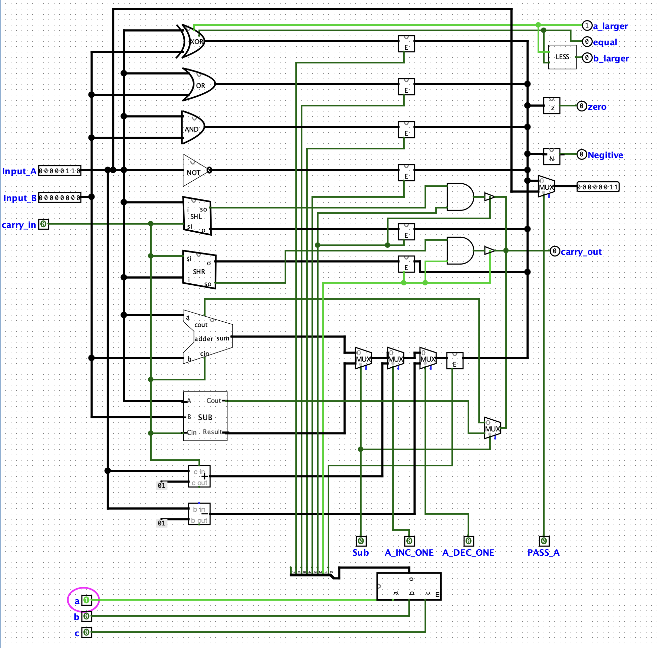

Phase Four
1. Write a program that adds operands until the new value to be added is 0.
R1:Input_A, R2:Input_B

LOOP:
ADD R1, R2 ; Add value in R2 to R1 (accumulate)
BRZ R2, END ; Exit loop if R2 is 0; assume R2 is updated externally each time
JMP LOOP
END:
; Done

2. Write a program that shifts the content of a register until the least significant bit is 0.

CHECK_ALL_ONES:
CMP R1, 255 ; Check if R1 == 11111111
BRZ R1, STOP ; If all bits are 1, stop shifting

SHIFT_LOOP:
SHR R1 ; Shift R1 right by 1
BRLSB R1, END ; If LSB is 0, exit loop
JMP SHIFT_LOOP
END:
; Done
STOP:
; Value was 11111111, skip shifting

